CT perfusion imaging of the liver

# Introduction

* Computed tomographic (CT) perfusion imaging of the liver provides functional information about the microcirculation of normal parenchyma and focal liver lessions
* many of the limitations of early CT perfusion studies in the liver, such as limited coverage, motion artifacts, and high radiation dose of CT, are being adressed by recent technical advances
* several issues remain, such as paucity of large mulitcenter trials, limited accessibility of perfusion software, and lack of standardization methods

# Essentials

* The liver is one of the most challenging organs for perfusion imaging, due to its unique dual vascular supply and considerable nonuniforma motion during respiration
* current CT perfusion protocols enable measurements of blood flow characteristics through dynamic CT aquisitions following intravenous administration of contrast agents
* CT perfusion of the liver is a promising technique for assessing the efficiency of various anticancer therapies, for diagnosing primary or metastatic tumors, for predicting early response to anticancer treatments, and for monitoring tumor recurrence

# Basic principles

* CT perfusion is based on the increase and subsequent decrease of contrast agent concentration in tissues as a function of time
* CT perfusion analysis is based on several fundametnal requirements. One is sequential CT scanning of the same volume over time, performed before, during , and after intravenous administration of contrast agents to trace the temporal changes in CT attenuation in the tissue volume of interest
* Two phases: in the first phase, the enhancement is determined to a great extent by the blood flow, while in the second phase, the enhancement depends on the blood volume and the permeability of capillaries to the contrast agent
* another requirement for perfusion CT is the selection of a vessel supplying the tissue of interest to obtain a time-intensity curve by placing a region of interest (ROI).
* a third requirement of CT perfusion analysis is the application of kinetic models to calculate various perfusion parameters in the tissues being analyzed.
  + **model-free maximum slope method**
  + **compartment model-base method**
  + **distributed parameter model-based method**
* The typical CT perfusion protocol consists of a precontrast image aquisition followed by dynamic image acquisitions performed sequentially after intravenous injection of an iodinated CT contrast agent

# Calculation of CT perfusion parameters

* imaging preprocessing steps should be performed
  + motion correction or image alignment
  + selection of arterial (and/or portal) input functions
  + ROI definition
  + voxelwise computation of perfusion parameters
* the effective time-intensity curve obtained from liver tissue is therefore a result of an overlay of both the arterial and the portal venous components
  + several diseases such as liver cirrhosis and primary and metastatic liver tumors lead to a global or regional perfusion changes toward increased hepatic arterial blood flow and decreased portal venous flow

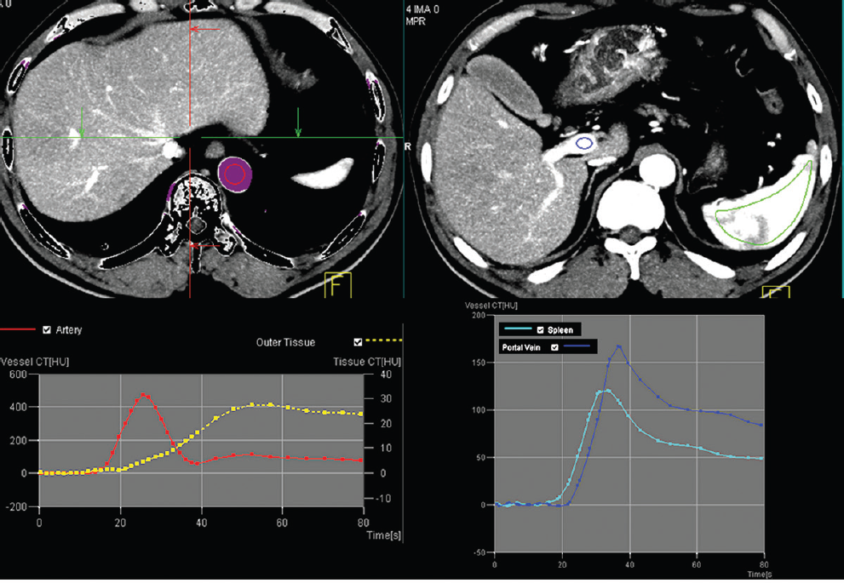

Figure - after motion correction, ROI with proximal abdominal aorta is drawn to obtain arterial input function (red circle, top left). Second ROI for portal vein is drawn to determine portal venous input function. A third ROI is drawn over spleen which allows separation of arterial and portal venous flow in the liver. Time intensity curves are generated.

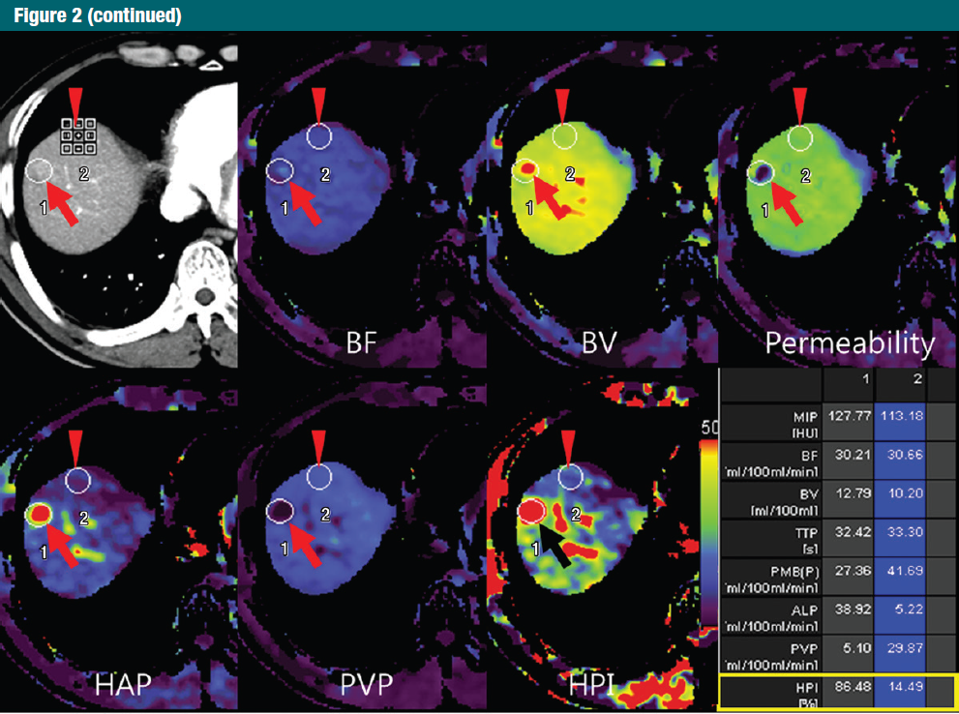

Figure - Perfusion software used to automatically generate color-coded perfusion maps of entire liver representing blood flow (BF), blood volume (BV), permeability, hepatic arterial perfusion (HAP), portal venous perfusion (PVP) and hepatic perfusion index (HPI).

Define regions of interest for hepatic nodules (metastasis, arrow) and normal parenchyma (arrowhead) to analyse quantitative perfusion parameters.

In the model-free maximum slope method, time to peak splenic anhancement (the end of arterial phase and beginning of the portal venous phase of liver perfusion) is used for separating HAP and PVP.

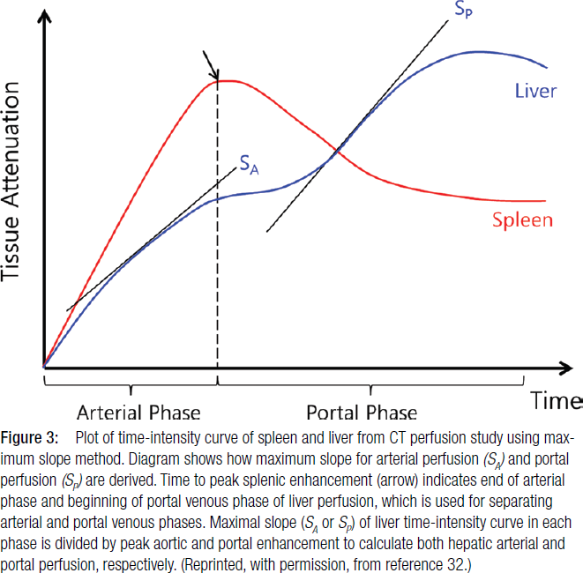

HPI = arterial perfusion /(arterial + portal perfusion) can be calculated from HAP and HPP. The maximum-slope method does not allow calculating other perfusion parameters, such as blood volume, mean transit time (MTT), or capillary permeability surface product because it takes into account only the first-pass part of the liver enhancement curve before venous outflow.

Kinetic models applied to the liver vary according to the physiologic and hemodynamic assumptions made

* single-input vs. dual input models
* single compartment vs. dual-compartment models
  + single-compartment models assume that the intravenously administered contrast agent is confined to only ne compartment (vascular space), dual compartment models assume vascular space and the interstitial space

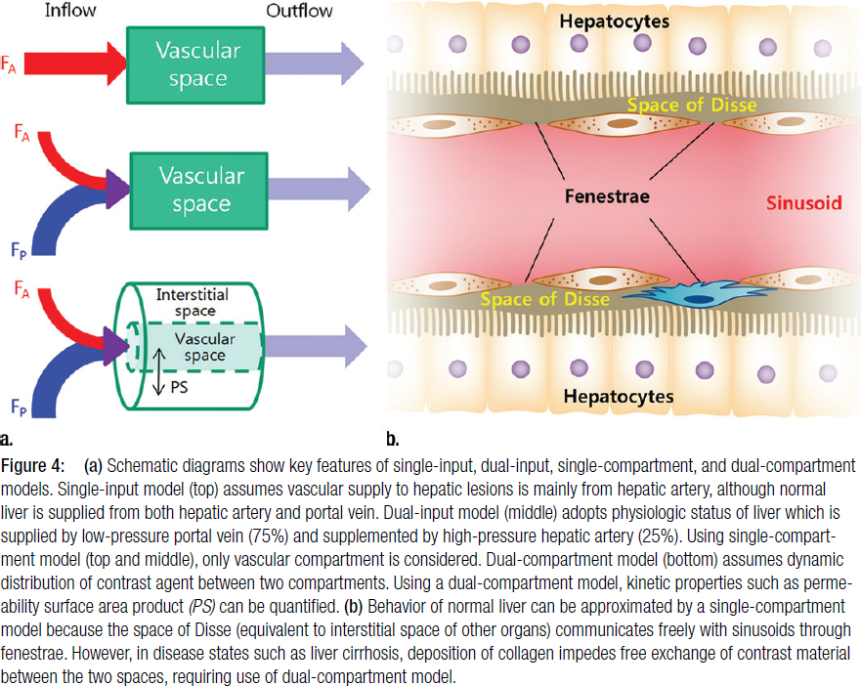

# 

# Challenges

* high radiation dose is one of the most serious issues
* lack of standards and protocols
* reproducibility
  + coefficient of variation of 5.% for HAP of normal liver tissue
  + correlation coefficients of ~0.9 of parameters for subsequent measurements
  + unclear what the effect of the different models for analysis is, but probably substantial
* motion correction
  + large challenges in liver perfusion due to considerable nonuniform and large motion during respiration
  + correction via software, only few studies assessed the effects of motion compensation on quantitative liver CT perfusion

# References

Kim, S. H., Kamaya, A., & Willmann, J. K. (2014). CT Perfusion of the Liver: Principles and Applications in Oncology. *Radiology*, *272*(2), 322-344.